JOB ?
A Job is created when you perform an action in Spark. (One action = one job
)
Ex: collect()
count()
show()
write()

STAGE ?
A Stage is a subset of a job that can be executed without shuffle. (Stage = group of tasks
)
Stages are divided based on wide transformations (shuffle boundaries)
• Narrow transformations → same stage
• Wide transformations → new stage

TASK?
A Task is the smallest unit of work in Spark. Each task processes one partition

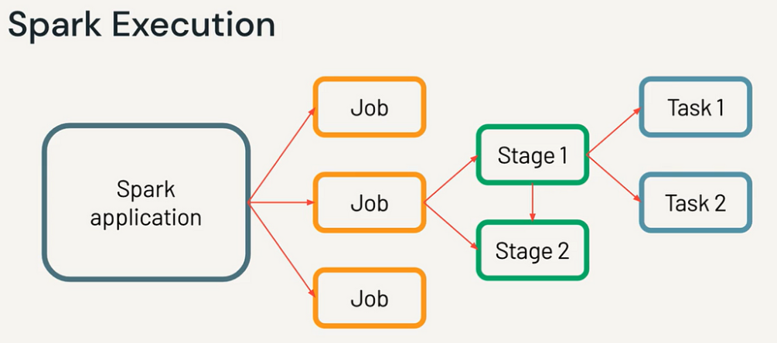

AQE (Adaptive Query Execution)
AQE is a Spark optimization feature that dynamically changes the execution plan at runtime based on actual data statistics.
Why AQE is needed?
👉 Normally, Spark creates a plan before execution 👉 But data characteristics may differ at runtime
👉 AQE fixes this by optimizing during execution
Key Features of AQE
1. Coalesce Shuffle Partitions
- Reduces number of small partitions after shuffle
- Improves performance
Switch Join Strategy
- Converts Sort Merge Join → Broadcast Join
- If one dataset becomes small at runtime
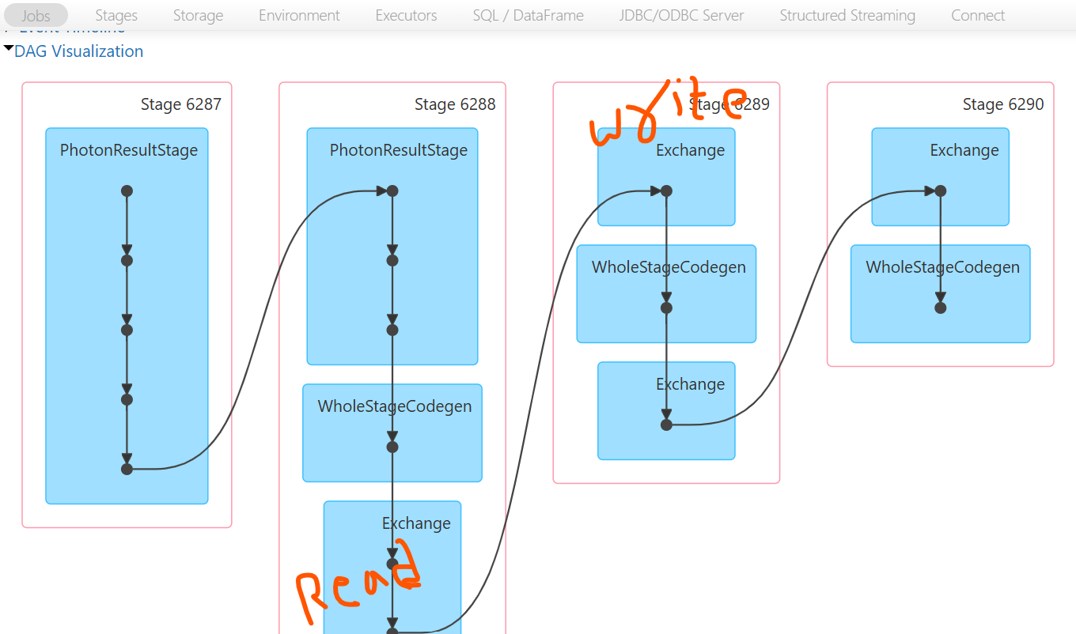

Feature | Catalyst | AQE | Tungsten
Stage | Planning | Runtime adjustment | Execution
Type | Logical/Physical optimizer | Adaptive optimizer | Execution engine
Focus | Query transformation | Runtime improvements | Performance
Handles skew | ❌ | ✅ | ❌
Code generation | ❌ | ❌ | ✅
Memory optimization | ❌ | ❌ | ✅

JOINS
Sort Merge Join (SMJ)
A Sort Merge Join is used when both datasets are large.It works by sorting and then merging the data on the join key

How it works
- Shuffle both datasets based on join key
- Sort each partition
- Merge matching keys
Key Characteristics
- ✅ Works well for large datasets
- ✅ Requires shuffle + sort
- ❗ Expensive (network + disk + CPU)
- ✅ Default join in many cases

df1.join(df2, "id")

Shuffle Hash Join
A Shuffle Hash Join builds a hash table on one dataset after shuffle and probes with the other dataset.

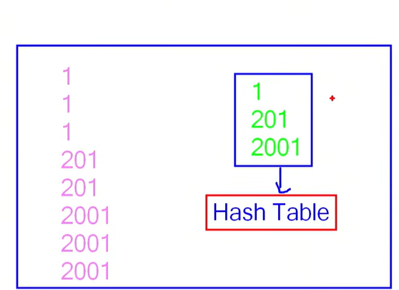
How it works
- Shuffle both datasets by key
- Build hash table on smaller partition
- Match with larger dataset
Key Characteristics
- ✅ Faster than Sort Merge Join (no sorting)
- ❗ Requires shuffle
- ❗ Needs enough memory for hash table
When - One side is smaller but not small enough to broadcast
👉 Spark prefers Sort Merge Join over this by default unless configured

Broadcast Join (Map-Side Join)
A Broadcast Join is used when one dataset is small.The small dataset is broadcast to all executors, avoiding shuffle. df1.join(broadcast(df2), "id")

Key Characteristics
- ✅ No shuffle (very fast)
- ✅ Best performance
- ✅ Used when one dataset is small (< ~10MB default)
- ❗ Limited by memory

Spark decides based on:
- Data size
- Config (spark.sql.autoBroadcastJoinThreshold)
- AQE optimization
spark.conf.get("spark.sql.autoBroadcastJoinThreshold") -- Default 10MB

In Databricks projects:
- ✅ Always try for Broadcast Join (best performance)
- ✅ Use repartition() before SMJ if data is skewed
- ✅ Enable AQE → improves join strategy automatically

